Project report

1.INTRODUCTION

* 1. Overview

Urban Aura Interiors is a design firm specializing in creating stylish and contemporary interiors for urban spaces. With a focus on blending functionality, aesthetics, and a touch of sophistication, Urban Aura Interiors aims to transform living and commercial spaces into vibrant and inspiring environments.

Urban Aura Interiors believes that urban spaces should reflect the unique personality and lifestyle of their inhabitants while maximizing the available space. Their design philosophy revolves around creating spaces that are visually appealing, comfortable, and highly functional, catering to the specific needs and tastes of their clients.

1.2 Purpose

Urban Aura Interiors is to enhance urban living and commercial spaces by combining aesthetics, functionality, and personalization. They strive to create environments that are visually appealing, comfortable, functional, and reflective of the unique lifestyle and preferences of their clients.

2.PROBLEMS DEFINITION& DESIGN THINKING

2.1 Empathy Map

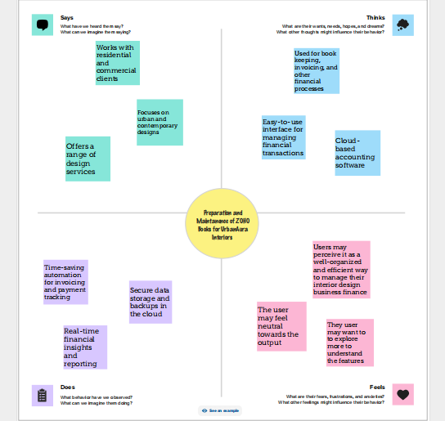

2.2 Idealization & Brainstorming Map

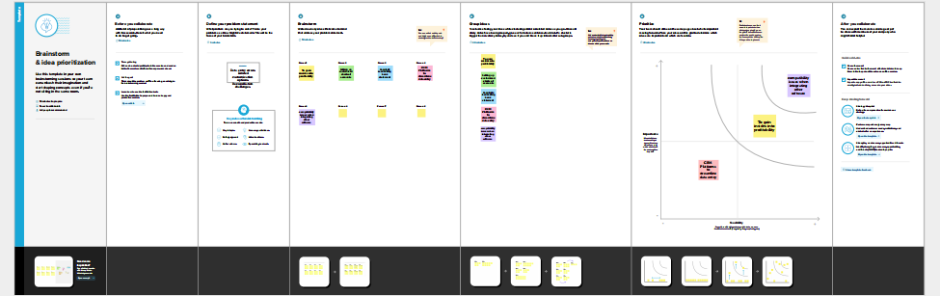

3.RESULT

* Profit & Loss Account

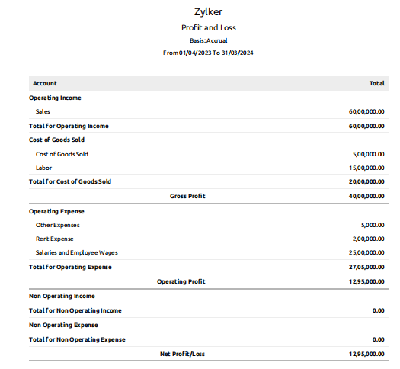

* Balance Sheet

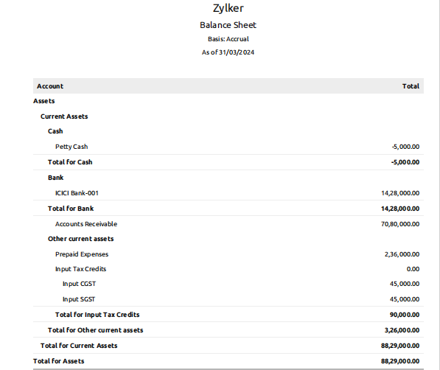

4.ADVANTAGES

& DISADVANTAGES

Advantages

* Professional Expertise
* Customized Design Solutions
* Optimal Space Utilization
* Aesthetically Pleasing Designs
* Seamless Project Management
* Access to Resources and Network
* Value for Investment

Disadvantages

* Cost
* Limited Availability
* Design Style Suitability
* Lack of Client Control
* Dependency on External Contractors
* Limited Geographic Reach
* Potential Communication Challenges

5.APPLICATIONS

The name of our Interiors is :

* URBAN AURA INTERIORS

This interiors is located and applied in the following address :

* URBAN AURA INTERIORS

5/ 375 G Maruthi Nagar,

Teacher’s colony , K.R.Nagar(Post),

Rajapalayam - 626108.

* Contact NO : 9876543210
* EmailID:urbanaurainteriors@gmail.com

6.CONCLUSION

Urban Aura Interiors is a professional design firm that specializes in enhancing urban living and commercial spaces. They offer a range of advantages, including professional expertise, customized design solutions, optimal space utilization, aesthetically pleasing designs, seamless project management, access to resources, and value for investment. They strive to create visually appealing, functional, and personalized interiors that reflect the unique preferences and lifestyle of their clients.

However, it's important to consider some potential disadvantages as well. These include the cost associated with hiring a professional firm, limited availability, potential differences in design style suitability, the need to relinquish some control over the decision-making process, dependency on external contractors, limited geographic reach, and potential communication challenges.

7.FUTURE SCOPE

As sustainability continues to gain importance in the design industry, Urban Aura Interiors can further expand their expertise in sustainable design practices.Urban Aura Interiors can stay at the forefront of this trend by incorporating smart home features seamlessly into their designs, creating technologically advanced and convenient living environments.Urban Aura Interiors can explore incorporating elements such as biophilic design, natural lighting, sustainable materials, and spaces that facilitate relaxation and rejuvenation. Urban Aura Interiors can contribute to this trend by specializing in transforming old or underutilized spaces into functional and attractive environments, breathing new life into urban areas.Urban Aura Interiors can leverage these technologies to enhance the design process, allowing clients to have a more immersive and accurate understanding of their proposed spaces.

8. APPENDIX

